Contents

External Axial Bolt load Calculations 1

Static loading conditions: 3

Bolts to bolt down the mount to base plate and floor: 4

Shear Force: 5

External Calculations too hard to compute. Need to find spring constant kb and kc of the bolt and clamping material respectively, however, from my brief research, the diameter and length of bolt is need to find out the spring constant, which I’m already trying to find out the diameter size of the bolt in the first place. Using Static loading conditions below instead.

Calculations have been done for the motor’s shaft parallel to floor, along with perpendicular to floor, to obtain the maximum forces of each (axial and shear). To calculate the exact forces, trigonometry could be used to obtain more exact forces, however, via Dulneth’s FEA analysis, M4 bolts to bolt the motor to the mount should be sufficient, which aligns with my shear force findings.   
  
The base plate/triangle angle wedge which the motor mount will bolt into, the bolts that bolts down the base plate/ triangle angle wedge will mostly undergo the weight force the support components, so I am confident that 4 or 6 M4 size bolts, with sufficient length should hold up.

## External Axial Bolt load Calculations

**Tensile Force (axial):**

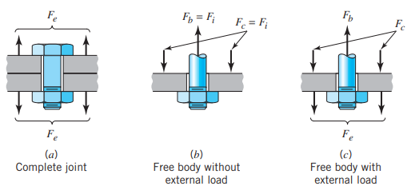

**(FBD of bolt tensile study)**

From the diagram above, the separating force Fe has to equal to the sum of the increased bolt force plus the decreased clamping force.

** (1)**

From Hooke’s Law:

** (2)**

Substituting eq (2) into (1):

**(3)**

Combining eq (2) and (3):

Therefore the equations for Fb and Fc are:

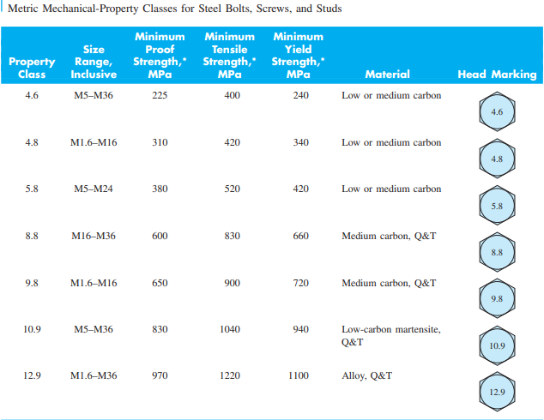

# Axial Bolt - Static loading conditions:

Calculation of Axial force for the bolts that holds down the motor, with motor shaft perpendicular to floor:

**Decisions/Assumptions**

* Using 4 bolts
* A load of 84.4N (Factor of Safety of 1.5 of 57N) is applied to each axially.
* 4.8 steel grade bolt low carbon steel has been selected with Proof Strength of 310 MPa.

**Design Analysis:**

* Due to a relatively low torque motor, a low grade steel of class 4.8 has been chosen.
* Due to the relatively low endangerments to human life, a factor of safety for 2.5 would be sufficient. Thus, 84.4 x 2.5 = 211N per bolt.

Using the equation,  σ = P/A:

310 MPa = 211N/At.

Tensile Stress Bolt Area, At = 0.68 mm^2

Using Table 10.2 above, it seems that a 1 -2 mm diameter bolt will be sufficient even though the table above does not go below 3mm nominal diameter. Therefore, bolt selection to hold the motor is based on the availability of the bolt (and nut).

Tightening Tension:



Tightening Torque:



## Bolts to bolt down the mount to base plate and floor:

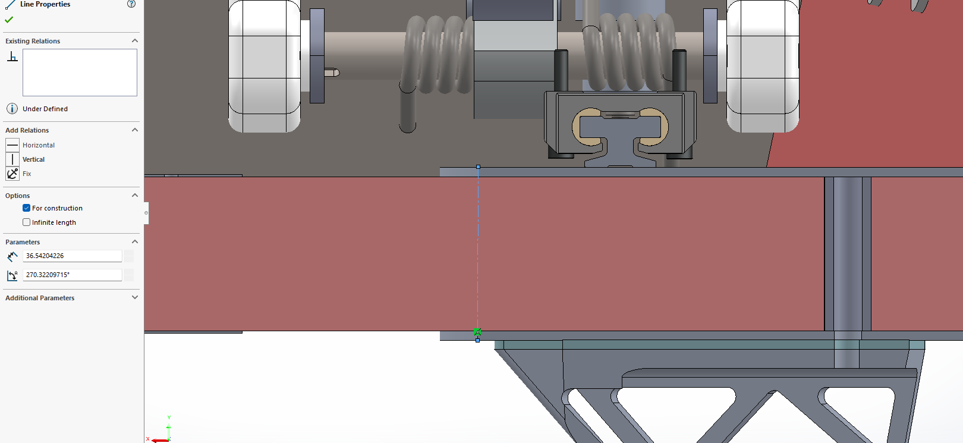

Honeycomb + the inserts width: 36.5mm.

## Shear Force – Bolts that holds down motor - Motor Shaft Perpendicular to Floor:

Assumptions:

* Bolt is tightened to full proof load.
* Bolt is in double shear with the inserts and honeycomb structure.
* A load of 84.4N (Factor of Safety of 1.5 of 57N) is applied to each bolt axially.
* 4.8 steel grade bolt low carbon steel has been selected with Proof Strength of 310 MPa.

**Design Analysis:**

* Due to a relatively low torque motor, a low grade steel of class 4.8 has been chosen.
* Due to the relatively low endangerments to human life, a factor of safety for 2.5 would be sufficient. Thus, 84.4 x 2.5 = 211N per bolt.

In double shear, the average shear stress:

|  |  |  |  |
| --- | --- | --- | --- |
| *τ*ave  = | |  | | --- | | *F* | | 2*A* | |

Where F is the applied force and A is the shear bolt Area.   
Selecting a M4 size bolt, which d = 4mm:

|  |  |  |  |
| --- | --- | --- | --- |
| *τ*ave = | |  | | --- | | *211N* | | 2× $\frac{π4^2 }{4}$ | |

= 8.4 N/mm^2 = 8.4 MPa

**Comparing with the allowable shear stress:**

The maximum allowable shear stress:

τmax​=0.6×Proof Strength

= 0.6 x 310 MPa = 186 MPa

Applying a FOS of 2.5:

Τallowable = 186/2.5 = 74.4 MPa

Since 8.4 MPa is significantly under 74.4 MPa, this indicates that a M4 grade bolt with a 2.5 factor of safety applied will withdraw the applied load.

## Steering Angle derived from Solidworks model:

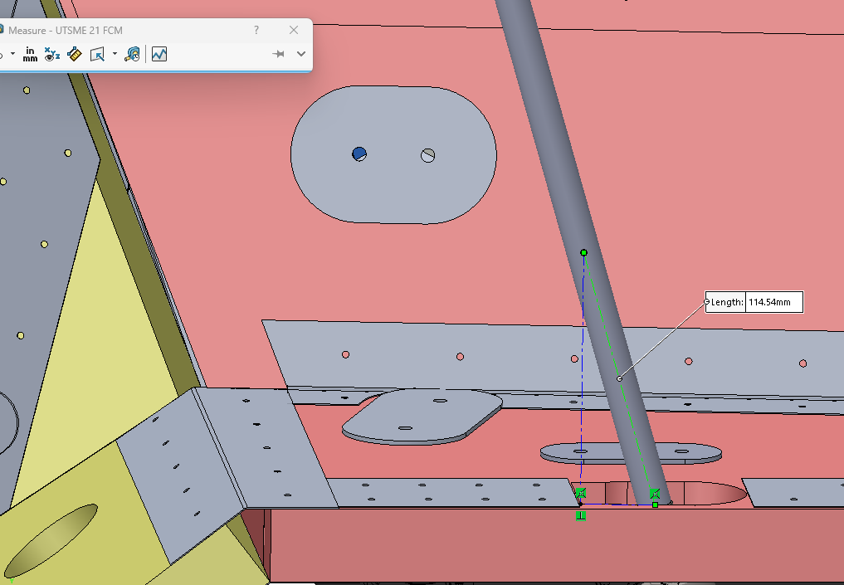

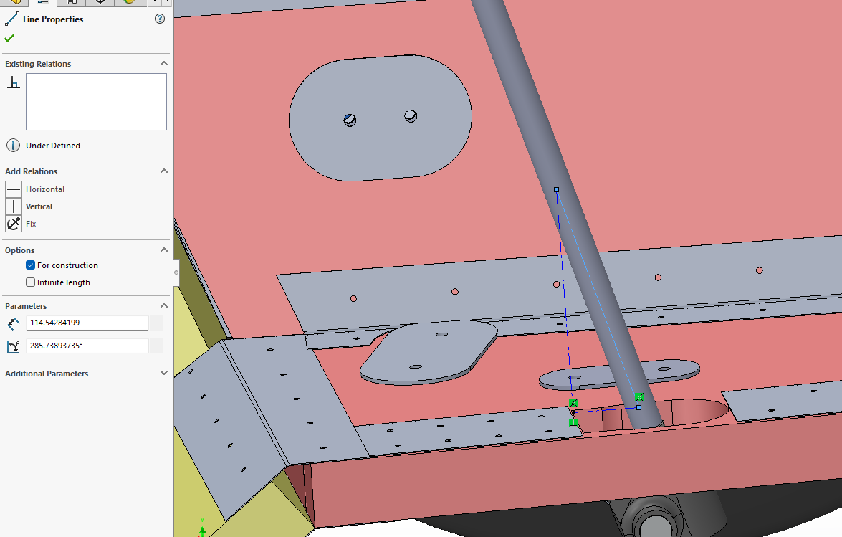

Small angle: 360 – 285.739 = 74.261

Large angle: 180 – 74.261 = 105.739

References:

Fundamentals of Machine Component Design. (ROBERT C. JUVINALL, KURT M. MARSHEK)

https://www.engineeringarchives.com/les_mom_singledoubleshear.html